SSI Specialty Course: Night / Limited Visibility
"Diving at night means excitement, adventure and fascination all at the same time!"
The underwater world is a new and mystical world for us.
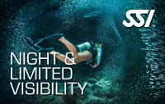
While diving at night you can discover a different side of this world and you can experience it from a completely different view.
It is an unbelievable feeling to discover the mysteries held underwater when the sun goes down.
With the right equipment and a powerful torch there is a lot to discover. Night diving is a whole new way to experience the underwater world.
If you want to learn more about NIGHT AND LIMITED VISIBILITY, you can buy the manual or the DVD even if you don t want to sign up for the course.
Course Content:
- Night vs. Limited Visibility Diving
- Special Equipment
- Preparing For The Dive
- The Dive
- Advanced Techniques

