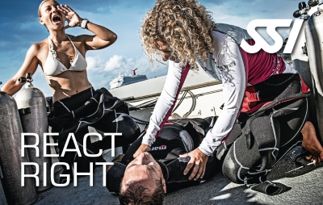

Emergency Training

REACT RIGHT - An Indispensable Tool For Unexpected Emergencies
REACT RIGHT is SSI s Emergency Training Program. Learn the "How-To" of First Aid, CPR, AED and Oxygen administration in diving emergencies as well as emergency assessment, so that any emergency situation can be evaluated properly.
Enrolling a REACT RIGHT program will increase your diving safety and comfort significantly. Also SSI and other training agencies require a valid First Aid and CPR Certificate as a prerequisite for the Diver Stress & Rescue certification.
The REACT RIGHT Student Kit includes a field reference guide which enables you to learn all theoretical knowledge easily. You will be guided through all practical skills by a REACT RIGHT Instructor. The program covers:
- Primary Assessment
- First Aid & CPR Skills
- Primary Stabilization Techniques
- Oxygen Administration in Diving Emergencies
- Automated External Defibrilation Basics

