SSI Specialty Course: Navigation
Have you ever asked yourself, "How does my instructor manage to find the way back to the exit point or to the boat?"
If so, the NAVIGATION Program is what you need to learn this skill for yourself.
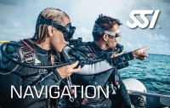
The NAVIGATION Program will teach you to navigate with a compass and how to apply natural navigation skills.
You will also learn to estimate distances, navigate different search patterns, find your way to different marking points, and be able to get back to the exit point at any time.
If you want to know more about NAVIGATION, you can buy the manual or the DVD without signing up for the course.
Course Content:
- Natural Navigation
- Compass Navigation
- Combining Natural and Compass Navigation
- Special Navigation Situations
- The Sport of Navigation

